Covid-19 information for families

During the COVID-19 outbreak, the practice is operating in a very different manner.

Appointments will largely be conducted by telephone or even video rather than being face to face and we are very focussed on the large numbers of unwell patients that we are managing and supporting.

We would like to reassure you that we are still very much still here to help and support you with any concerns or queries you have. We are only too aware that children will continue to get unwell from the usual childhood ailments, unrelated to COVID-19 and will require the normal standard of care.

All community health and social care services remain in operation. Health visitors, 0-19 Teams, social care and workers, hospitals and GP practices (including ours), Out of Hours and 111 are all still providing care and support. Please call them if you have any concerns.

Our normal telephone / switchboard number remains the same for you to call us too. To ensure your call is appropriately prioritised and directed to the right clinician, please mention to the receptionists what your query or concern is about and also if your child is being given early help support; on a Child Protection Plan; on a Child In Need plan, or if you are looking after a child who is in foster care.

The following have some useful advice and suggestions that can help children and families cope with having to remain socially isolated, in lockdown and socially distanced from others in challenging times.

- Trusted websites for COVID-19 information

At the moment, there is a lot of coverage from all media and although it is important to stay informed, it might make you feel as if things are getting on top of you. Feeling stressed or anxious related to seeing lots of new stories about the impact of COVID-19 will be a common reaction. It is OK and quite normal to feel this way.

Try to only take advice from trusted government and health service websites. These have all the latest facts and figures to give consistent advice on how to prevent spreading, catching it and what to do if you think you have Coronavirus. Some are suggested below.

- NHS (nhs.uk) website COVID-19 advice
https://www.nhs.uk/conditions/coronavirus-covid-19/

- Government (gov.uk) websiteCOVID-19 advice
https://www.gov.uk/government/publications/coronavirus-outbreak-faqs-what-you-can-and-cant-do/coronavirus-outbreak-faqs-what-you-can-and-cant-do

- Websites offering advice on keeping safe online

- https://www.net-aware.org.uk/networks/
- https://www.thinkuknow.co.uk/parents/Support-tools/home-activity-worksheets/?utm_source=Thinkuknow&utm_campaign=03f521e658-TUK_ONLINE_SAFETY_AT_HOME_21_04_20&utm_medium=email&utm_term=0_0b54505554-03f521e658-55278849

- Managing an unwell child during social isolation and distancing

- https://www.what0-18.nhs.uk/national/coronavirus
- https://www.rcpch.ac.uk/sites/default/files/2020-04/covid19_advice_for_parents_when_child_unwell_or_injured_poster.pdf

Advice for parents during coronavirus

Whilst coronavirus is infectious to children it is rarely serious. If your child is unwell it is likely to be a non-coronavirus illness, rather than coronavirus itself.

Whilst it is extremely important to follow Government advice to stay at home during this period, it can be confusing to know what to do when your child is unwell or injured.

Remember that NHS 111, GPs and hospitals are still providing the same safe care that they have always done. Here is some advice to help:

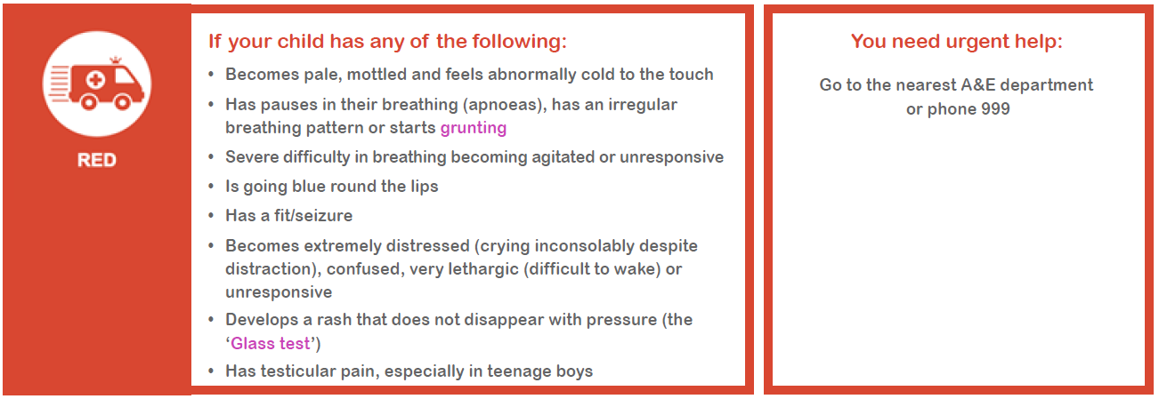
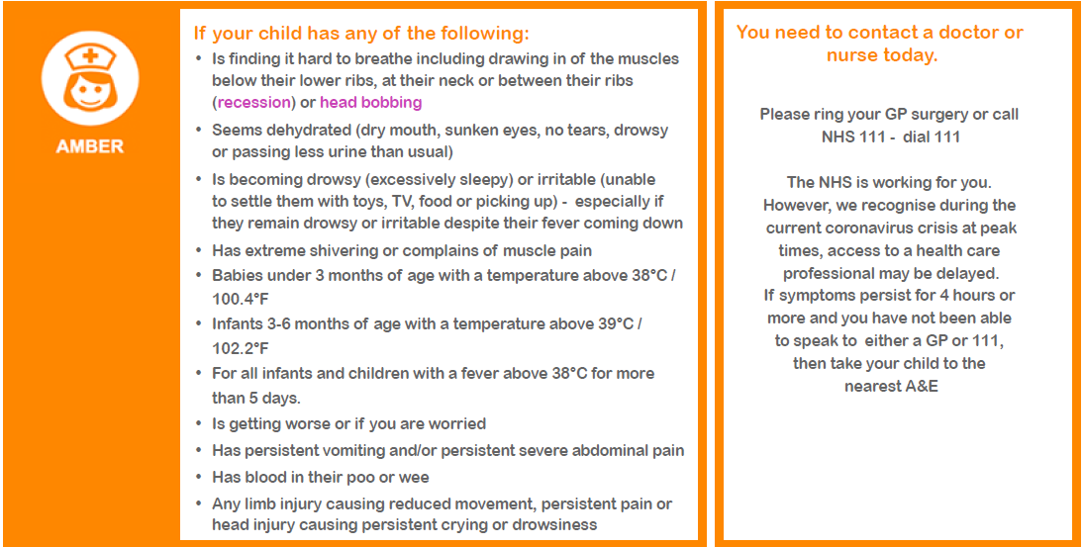
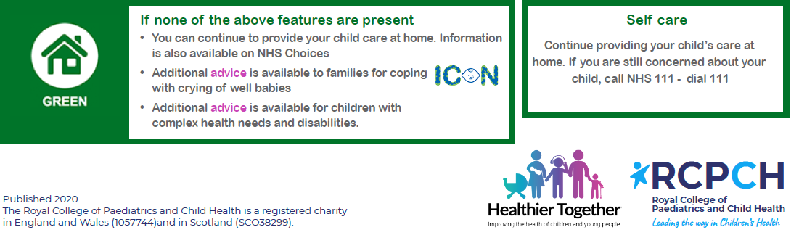

- Helping families with younger children cope with ‘social isolation and distancing’

For those of you with younger children in the household, we are aware how difficult it can be to get across the messages and explain what it means to be in ‘lockdown’ and to both socially isolate and distance from others. We hope you may find the following free resources useful to help your younger children follow the current restrictions in place.

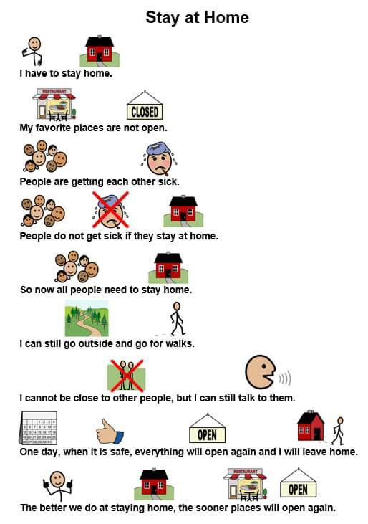

Also, checkout the free children’s book on Coronavirus, illustrated by Axel Scheffler, famed for the award winning ‘The Gruffalo.’: https://axelscheffler.com/books-for-older-children/coronavirus

- Helping families with older children cope with ‘social isolation and distancing’

For most children, try to develop and implement a new routine that all family members can follow. This will provides a balance of several different activities and appropriate interactions with others. At times like these, it can be easy to fall into unhealthy patterns of behaviour, which can make you feel worse.

Simple things you can do to stay mentally and physically active during this time include:

- Wake up relatively early – (annoying but it does help). Lying in bed until early afternoon will drain your energy levels and crush productivity. Set a nice alarm to wake up to and allow yourself more time to get ready and start the day properly.
- Stay connected to your friends and family via Skype, e-mail, video-calling and telephone / texting. Don’t rely just on texting though, as an audio-visual catch up is much more rewarding.
- Social media can be an excellent way to keep in touch with your friends and family. However, you should be mindful of your use of social media. Use it to promote positive interactions, and put your device away if it starts to negatively affect your mood. Many smartphones allow you to set time limits for certain apps such as Facebook or Instagram.
- It is important to maintain, where possible, some sort of daily routine. You should vary what you put into your routine to keep things different and interesting but try and include key elements consistently.
- Make a to-do list (or schedule / rota) with reasonable and specific things included. Finalise your schedule / rota the night before so you are ready and prepared for the day ahead. Include spending time doing things you enjoy as well as things you need to do.
  - Time to eat (breakfast, lunch and dinner)
  - Time to network chat and socialise, social media / gaming (IT based)
  - Time to do work, study, homework, coursework, learn, research
  - Time for exercise
  - Time for relaxing, personal downtime (non IT based)
  - Time to spend with family
  - Time to spend doing something fun / different / activity based
- Try to eat healthy, well-balanced meals, drink enough water, and try to avoid smoking, alcohol and recreational drugs
- If needing to socially isolate, spend time with the windows open to let in fresh air, arranging space to sit with a nice view if possible and get some natural sunlight. Get out into the garden or sit on your doorstep if you can, keeping a distance of at least 2 metres from others.
- If you don't need to isolate, you should try and get out of the house to do your daily exercise (walk, jog, run or bike-ride), keeping your social distance to at least 2 metres when outside.
- Look to introduce fun activities for you and the family
  - Themed meals
  - Special movie / Netflix nights
  - Quizzes and competitions
  - Kitchen dancing / Karaoke
  - Skype/FT friends other family to involve them too
  - Skype/FT friends other family to involve them too
- Getting a good night’s sleep is crucial for feeling emotionally healthy the next day. We all feel better after a good night’s sleep.

- Helping families with emotional and physical well-being

Having to be in ‘lockdown’, socially isolate and distance yourself (and your family) from your colleagues, friends and family members will make many of us feel stressed and anxious. These are truly extra-ordinary times where information and issues are changing extremely rapidly. It is not surprising that each day can feel totally different to the next and this is unsettling. What’s happening in the world right now can feel daunting, unable to make plans even for the immediate future - it’s very normal to feel worried and unsure about things.

We want you to look after yourself and your family during these difficult times. The following resources can help you and your family with your emotional and physical well-being.

Websites offering emotional well-being and support

- Childline (Free confidential help and advice for any Under 18 year old, whatever the worry)
https://www.childline.org.uk/
Call 0800 1111
- ICON (Babies cry: You can cope. Advice and support for parents coping with a crying baby)
http://iconcope.org/
- MIND (Mental Health Support with specific advice on ‘Coronavirus and your wellbeing’
https://www.mind.org.uk

- NSPCC Helpline (Worried about a child, unsure? Contact professional counsellors for help, advice and support)
Call 0808 800 5000
- Samaritans (Resources and help for all ages)
https://www.samaritans.org/
Call 116 123
- Young Minds (Supports children, young people, parents & carers with their mental health and well-being)
https://youngminds.org.uk

Websites offering advice on keeping fit, physical well-being

- Free 30 day Yoga course
https://www.youtube.com/watch?v=--jhKVdZOJM
- Herts sports partnership (workout from home)
https://sportinherts.org.uk/workoutfromhome/
- The Football Association (Staying fit at home)
http://www.thefa.com/get-involved/footballs-staying-home
- 21 best home exercises for men (workout from home)
https://www.menshealth.com/uk/building-muscle/a754099/the-15-best-beginners-exercises-to-do-at-home/

